The business center of the Russian-Vietnamese Friendship Society, together with the Export Support Center of the Republic of Khakassia and the Trade Representation of the Russian Federation in Vietnam, invites Vietnamese companies interested in delivering products from Russia to take part in a reverse business mission to the Abakan city
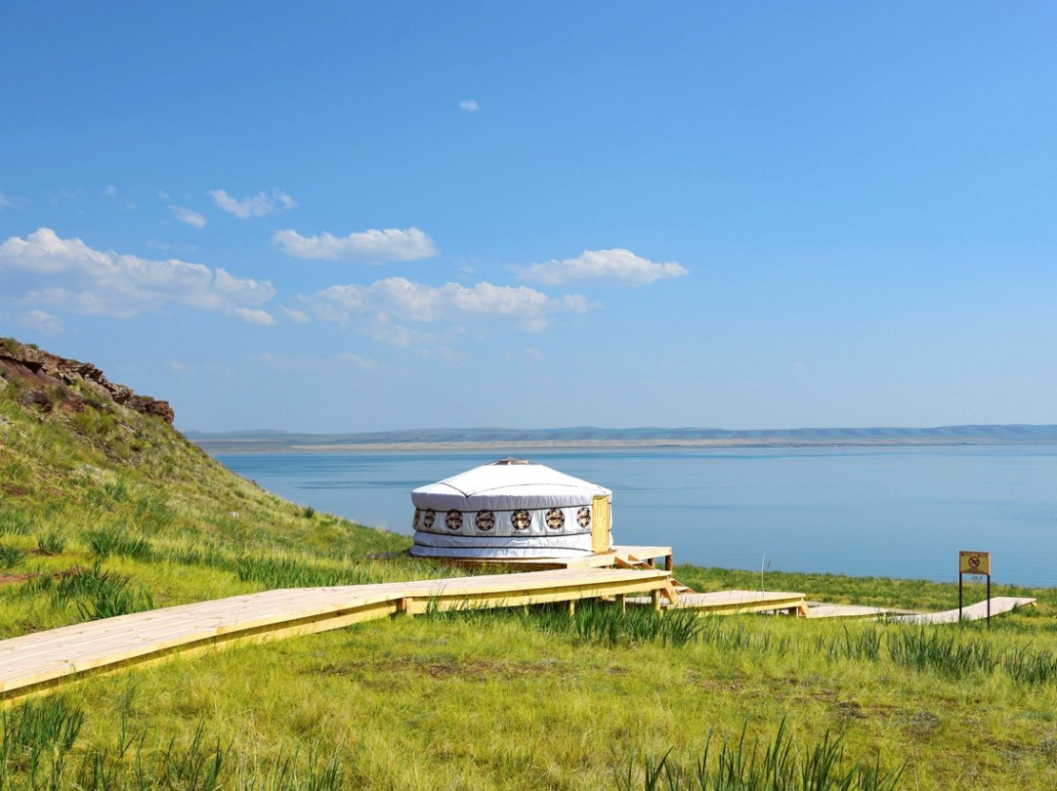

The trip will take place from November 21 to November 23, 2019 along the route Novosibirsk - Abakan - Novosibirsk

The main purpose of the trip is to introduce Vietnamese importers to export-oriented Russian manufacturers and assist in concluding direct supply contracts (without intermediaries). You will have the opportunity to participate in the Agricultural Exhibition, which will bring together farmers and agricultural enterprises from all over the region, visit production facilities, discuss the terms of cooperation, and establish business relations.
The main activities of exporters: woodworking (lumber, heat-treated and thermally modified wood), wild berries (blueberries, lingonberries, cranberries, etc.), mushrooms, fern, pine nuts, confectionery, food additives for farm animals, tourism)
For registration and questions:
reginav@inbox.ru Russian\English +7 963 6447575 (Whatsapp) Regina Budarina (Ms)
ms.lenachu@gmail.com вьетнамский +84 97 246 72 84 Miss Lien
